**Detect the distance of object**

**Name: C.S.CEBIN RAJA**

 Requirements

* -->esp32
* -->ultrasonic sensor pin number
* -->trigPin = 12
* -->echoPin = 14

**Circuit diagram:**

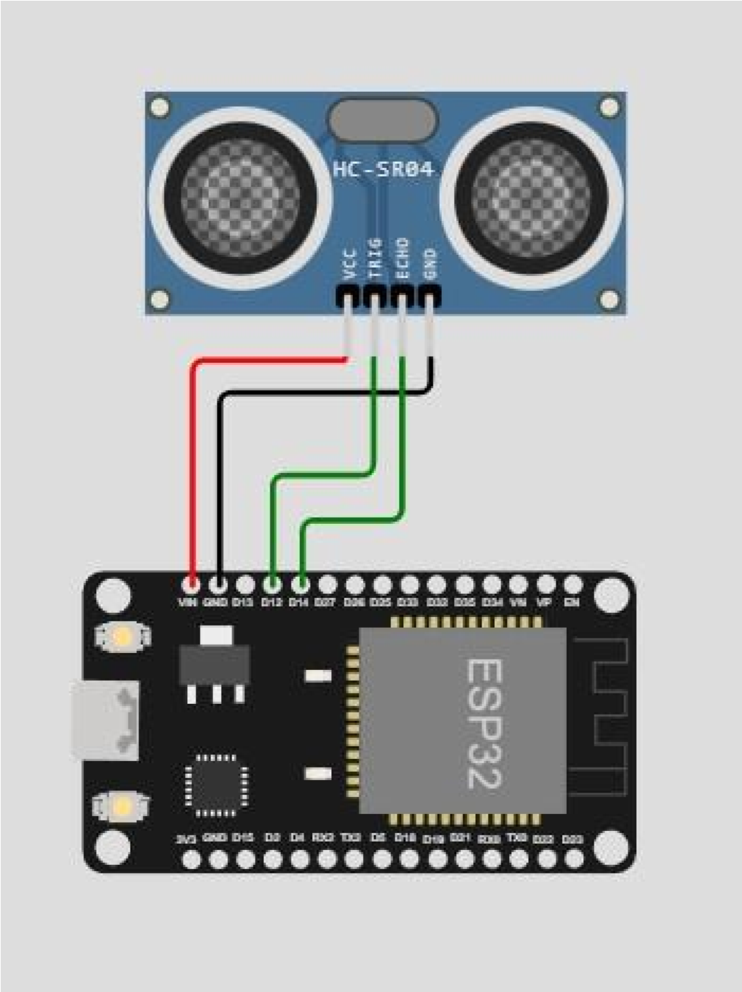

Source code:

const int trigPin = 12; const int echoPin = 14;

void setup() { **Serial**.begin(9600); pinMode(trigPin,

OUTPUT); pinMode(echoPin,

INPUT); } void loop() { long duration, distance; // Send ultrasonic pulse digitalWrite(trigPin, LOW);

delayMicroseconds(2); digitalWrite(trigPin, HIGH); delayMicroseconds(10); digitalWrite(trigPin, LOW);

// Measure echo duration duration = pulseIn(echoPin, HIGH); // Calculate distance in centimeters distance = duration * 0.034 / 2; distance = distance + 1 ;

int a = distance; if (distance < 20)

{

**Serial**.println("Warning: Distance is 20 cm!");

}

// Print the distance to the Serial Monitor

**Serial**.print("Distance: ");

**Serial**.print(distance);

**Serial**.println(" cm");

delay(1000);

}

**Link**: https://wokwi.com/projects/365228798371883009